Data Mining Applied to Major League Baseball Batters

Michael Taylor
CS 522: Data Mining
Hood College, Computer Science Department
Frederick, Maryland, USA
Mt10@hood.edu

Abstract – Major League Baseball maintains a large collection of statistics and metrics regarding each pitch a batter faces. It would be beneficial for major league teams to be able to predict with some certainty the pitch location where a batter will likely successfully obtain a hit. In addition to this analysis, it would be important for teams to be able to predict what pitch type and speed will likely produce a hit. Using classification, association and clustering we are able to make predictions to assist a major league pitcher.

Keywords—Data mining; Baseball, prediction, classification, association

- Introduction

With the amount of baseball statistics available in processable interfaces it is reasonable to extrapolate predictive analysis. Baseball teams pay exorbitant amount of money to firms in order to produce analysis of all players faced. With this in mind it is worthy to seek out simpler and possibly better solutions to the age old problem of baseball. For the sake of this experiment we will look into each batter's success based upon pitch type and pitch location, using cluster analysis and association rules.

- Background

The official start of Major League Baseball began in 1903 with the combination of the National League and American League. The sport, known as America’s pastime, has grown to be a multi-billion dollar industry. The nature of the sport allows statistics to appear heavily, with long seasons and multiple at bats per game, the volume of data becomes massive.
Statistics have changed the way modern baseball is being played. Currently teams are shifting their defenses to the tendencies of the hitter at the plate. In the past three years the number of shifts has increased from less than 3000 to well over 12000. This massive change is likely due to the amount of data being process Major-league organizations.
Major league baseball games can be won and lost in a single pitch, as every batter represents a scoring opportunity. Each hit a batter obtains greatly increases the scoring potential for their team. For this reason it indicates the necessity of a predictive function on the effectiveness of specific pitches and pitch locations given a batter.

- Approach and Methodology

For the sake of this experiment data has been gathered for the current Major League Baseball season from the website, http://gd2.mlb.com/components/game/mlb/year_2015/, which is run by MLB. The amount of data is limited to this season only, but could be extended to cover the each players entire career.
After the data is collected it will be inserted in an SQL data base with the format:

Field | Type | Null | Key | Default | Extra
id | varchar(50) | Yes |  | Null
name | varchar(50) | Yes |  | Null
des | varchar(50) | Yes |  | Null
pitch_type | varchar(50) | Yes |  | Null
x | Float | Yes |  | Null
y | Float | Yes |  | Null
start_speed | Float | Yes |  | Null
end_speed | Float | Yes |  | Null

Where the following terms are defined as:

id: Unique identify for each player.
name: Players first and last name.
des: Result of the pitch.
pitch_type: Specific type of pitch, for example curveball.
x: Pitch location on the x axis.
y: Pitch location on the y axis.
start_speed: Speed of the pitch when leaving the pitcher's hand.
end_speed: Speed of the pitch when reaching the catcher.

In order to produce accurate predictions the data must first be classified. For the sake of this experiment we have removed the number of bases obtained by a specific batter, results of each pitch will be classified as: Hit, Ball, Strike, and Ignore.

Hit: Any pitch resulting in the batter reaching any base by way of a hit and not existing in the ignore category, this includes singles, doubles, triples and homeruns.
Strike: Any pitch resulting in a strike which is not in the ignore category, this includes Called Strikes and Swinging Strikes.
Ball: Any pitch resulting in a ball.
Ignore: Pitch results which for the reason of analysis are ignored, this includes, pitchouts, bunts, missed bunts, and Hit by pitch.

Additionally, the speed of the pitch is rounded to the nearest number divisible by 5, for example 83 miles per hour becomes 85 miles per hour.
After the data has been classified to enable data processing the pitch locations of successful hits is processed by a DBSCAN algorithm originally presented by Jörg Sander, Martin Ester, Hans-Peter Kriegel, and Xiaowei Xu in their paper “Density-Based Clustering in Spatial Databases:The Algorithm GDBSCAN and its Applications” for the University of Munich. This produces a cluster map of successful hits.
Along with this cluster map of successful hits the data is fed through an association algorithm to produce rules of pitches to avoid allowing the hitter to reach base. The data is fed to the Apiori Algorithm originally proposed by Agarwal and Srikant in their 1994 paper, “Fast Algorithms for Data Mining Association” published by the IBM Almaden Research Center. The algorithm effectively reduces the large data set to produce association rules to enable prediction.

- Results

In recent weeks the Baltimore Orioles have obtained a new outfielder by name of Gerardo Parra. In order to get to know this player some more we can use the algorithms to produces predictive analysis of his at bats.
The first figure that is produced is a cluster analysis of his successful hits:
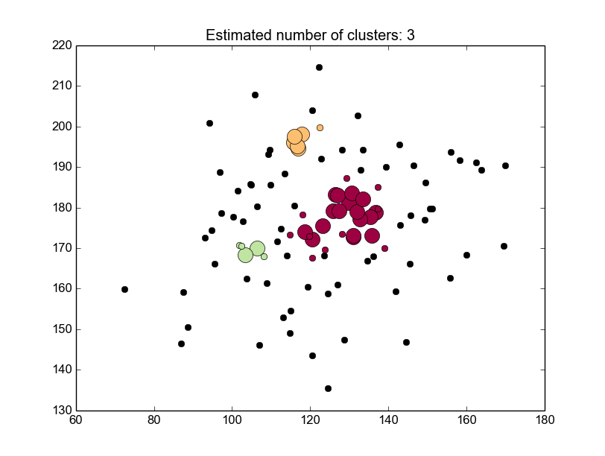
From this clustering we can see that Parra is a very good hitter at any ball in the center of the strike zone, with a large cluster. Additionally, two small clusters appear at the top of the strike zone and the low and inside portion of the strike zone. Parra has been a very good hitter this year, but from the clustering we can see a weakness at the bottom of the strike zone where he becomes more inconsistent.
From the association rules created by the algorithm we can observe in which situations Parra excels:
(85, 90, 'Hit') Instances: 22 : Confidence: 1 support: 0.209523809524
(95, 'Hit', 'four-seam fastball') Instances: 23 : Confidence: 1 support: 0.219047619048

With high confidence we can see that hits for Parra come in the situations when the ball begins at 85 mph and ends at 90 mph and 95 mph four seam fastballs.
Using the algorithm we can explore other players' strengths. Last year's American League MVP, Mike Trout, is a good example. Trout is seen as one of the best hitters in the game, which is observable in the cluster analysis of his hits:
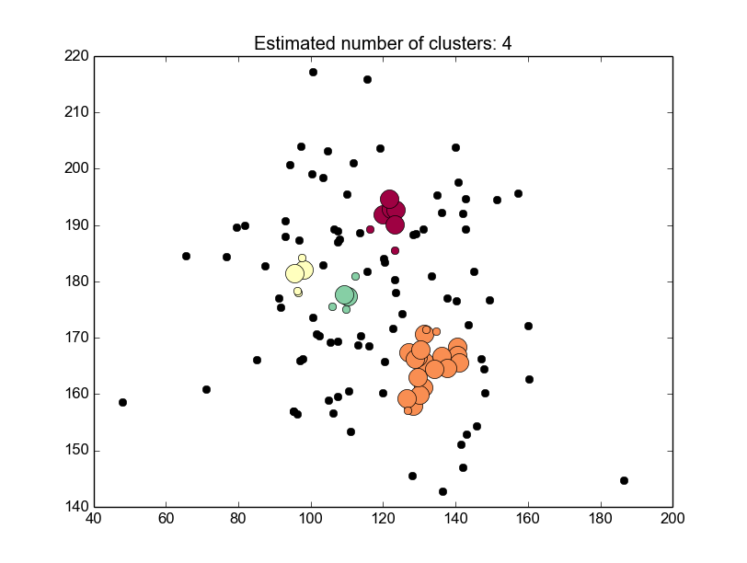
Using this an opposing pitcher must avoid the outside corner, center and top of the strike zone. would suggest that the opposing pitcher pitch mainly to the inside corners.

- Conclusions

From the results of this experimentation one can reach the conclusion that data analytics, specifically clustering and association analysis can be good tools for the use in major league baseball. From player scouting to game time decisions, the algorithms appearing here have shown that there is valuable information to be gleaned.

- Future Work

This experimentation can be expanded in multiple ways. First, it would be interesting to expand this data to each players entire career. This would produce a much larger sample size with which more interesting and complete analysis can be obtained. This data would have to be weighted giving more weight to more recent data, player tend to evolve over the course of their careers.
An additional area this experimentation can be furthered is to apply weights to the total number of bases each hit reaches. A players home run zone is more important to be avoided than singles. This could also lead to changes in association rules.
One final area this study could be furthered is by including specific situations. It would be important for pitchers to have a predictive analysis of what pitch to throw in order to induce a double play.

- References

[1]T. Pearson, 'History of Major League Baseball From Early Beginnings to Current', Thepeoplehistory.com, 2015. [Online]. Available: http://www.thepeoplehistory.com/baseballhistory.html. [Accessed: 11- Aug- 2015].
[2]D. Mittler, 'Increase in defensive shifts', ESPN, 2015. [Online]. Available: http://espn.go.com/mlb/story/_/id/11060210/defensive-shift-used-all-mlb-teams-espn-magazine http://citeseerx.ist.psu.edu/viewdoc/download?doi=10.1.1.63.1629&rep=rep1&type=pdf. [Accessed: 11- Aug- 2015].
[3]R. Agrawal and R. Srikant, 'Fast algorithms for mining association rules.', Proc. 20th int. conf. very large data bases, VLDB, vol. 1215, pp. 478-499, 1994.
[4]J. Sander, M. Ester, H. Kriegel and X. Xu, 'Density-based clustering in spatial databases: The algorithm gdbscan and its applications', ata mining and knowledge discovery, vol. 2, no. 2, pp. 169-194, 1998.

